Project Design Phase-II
Data Flow Diagram & User Stories

Date | 26 September 2026
Team ID | SWTID-2026-4413
Project Name | AI FAQ ASSISTANT
Maximum Marks | 4 Marks

Data Flow Diagrams:
A Data Flow Diagram (DFD) is a traditional visual representation of the information flows within a system. A neat and clear DFD can depict the right amount of the system requirement graphically. It shows how data enters and leaves the system, what changes the information, and where data is stored.

Example: (Simplified)


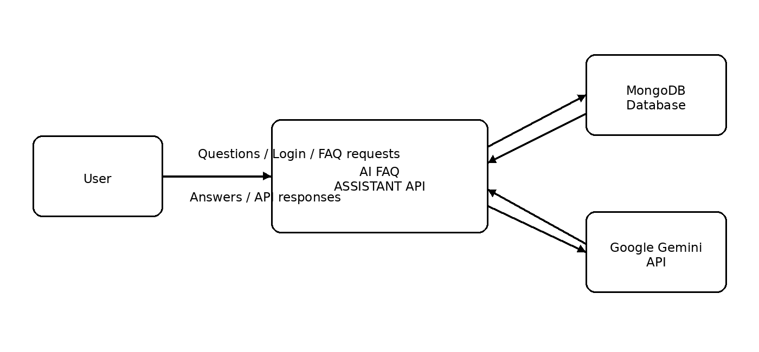
User Stories
Use the below template to list all the user stories for the product.
User Type | Functional Requirement (Epic) | User Story Number | User Story / Task | Acceptance criteria | Priority | Release
User | Registration | USN-1 | As a user, I can register for the AI FAQ Assistant using my email and password. | A valid user account is created and stored successfully. | High | Sprint-1
User | Login | USN-2 | As a user, I can log into the application using my email and password. | Valid credentials allow login and a JWT token is generated. | High | Sprint-1
User | Ask Question | USN-3 | As a user, I can submit a question to the AI FAQ Assistant. | The question is accepted and an answer is returned. | High | Sprint-1
User | AI Answer | USN-4 | As a user, I can receive an AI-generated answer to my question. | The system sends the question to the Gemini API and returns the generated answer. | High | Sprint-2
User | View FAQ | USN-5 | As a user, I can view available frequently asked questions and answers. | The requested FAQ information is displayed correctly. | High | Sprint-2
User | Search FAQ | USN-6 | As a user, I can search FAQs using a keyword. | Matching FAQs are returned for the entered search keyword. | Medium | Sprint-2
Administrator | Manage FAQ | USN-7 | As an administrator, I can create, update and delete FAQ records. | FAQ records are successfully added, updated or deleted in the database. | High | Sprint-2
Administrator | Generate FAQ | USN-8 | As an administrator, I can generate an FAQ from a given topic using AI. | The system generates a question and answer for the given topic. | High | Sprint-2

